[E123] Mash heater element

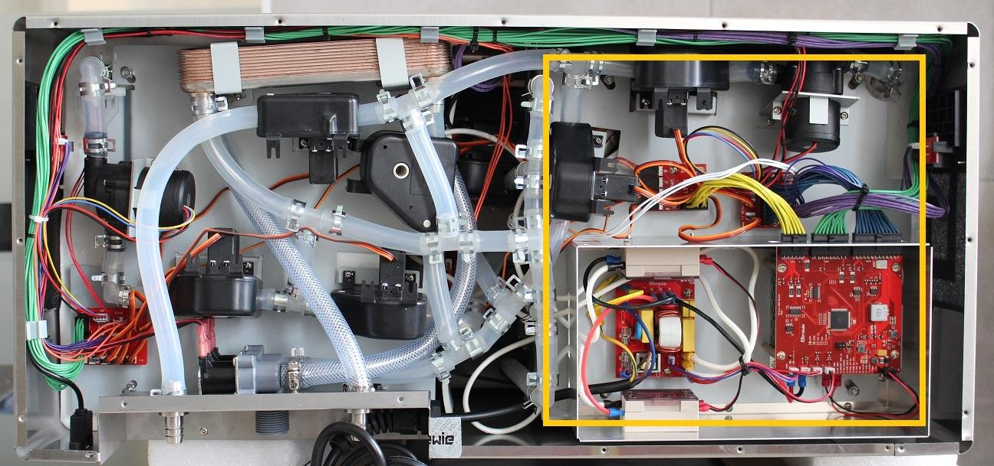

The mash heater element is located under the mash side service plate. To reach the heater element it is necessary to remove the whole plate:

1. Disconnect the silicone tube from the outlet of the mash tank by pulling off the clamp then the tube from the L fitting.
2. Disconnect the purple cable from button PCB.
3. Remove the cable bundle from the two marked holders.
4. Unscrew the marked 4 locknuts holding the mash plate.

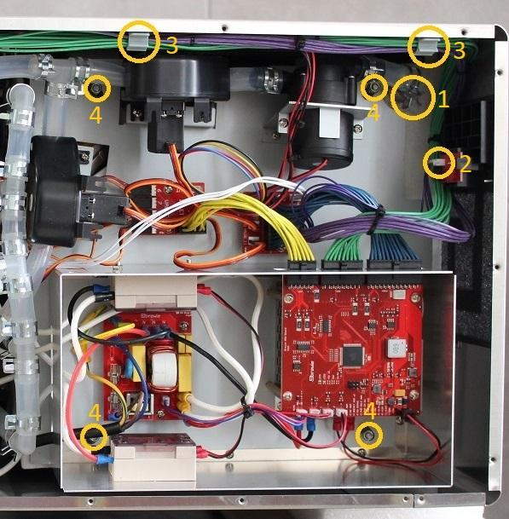

Open up the whole plate.

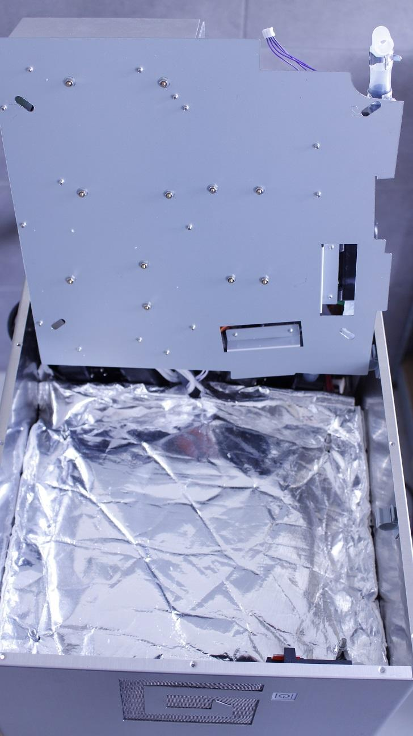

Carefully pull off the heat insulation from the threads and the outlet pipe.

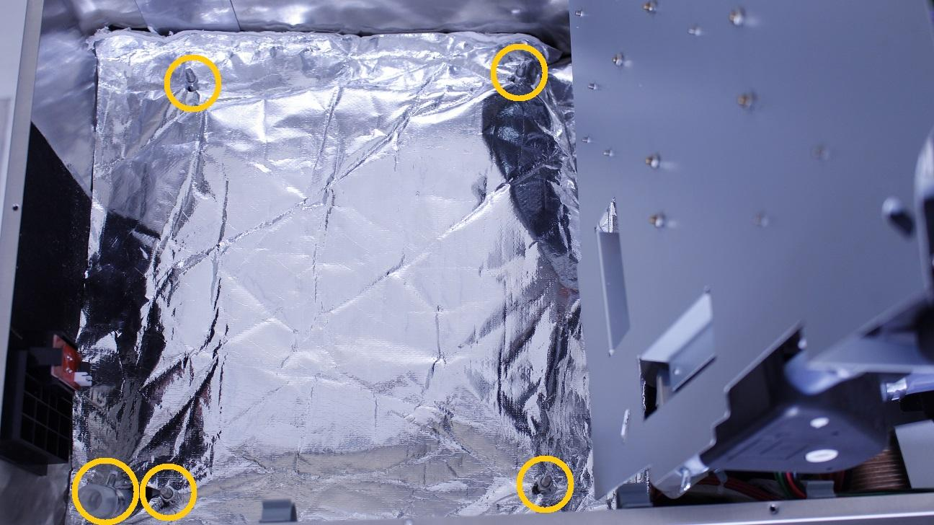

Simply turn the fastening clamps aside from the heater element and remove the isolation rubber.

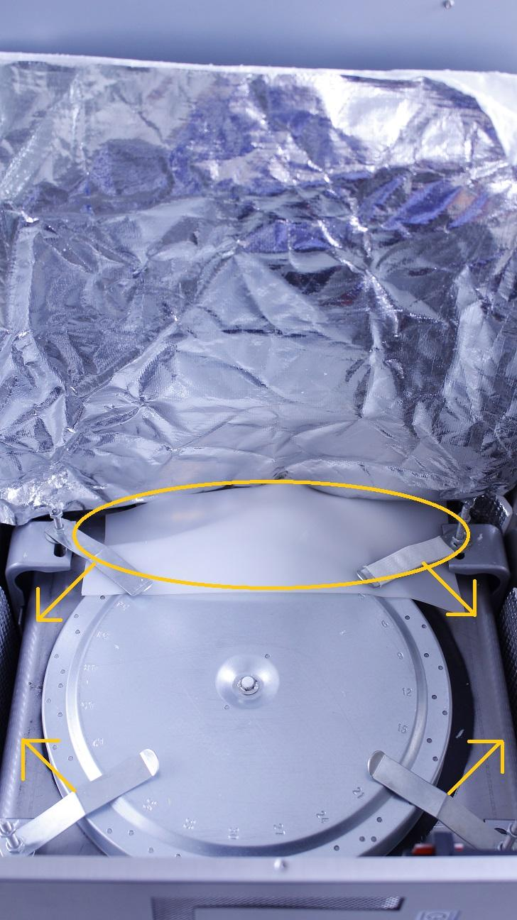

Cut the solidified adhesive to remove the cables from the pins of the heater.

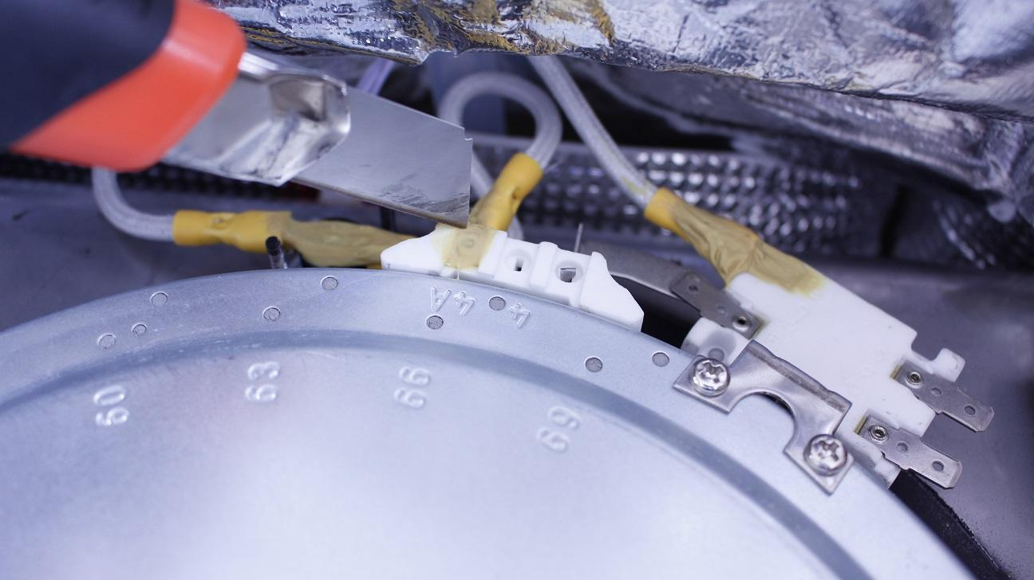

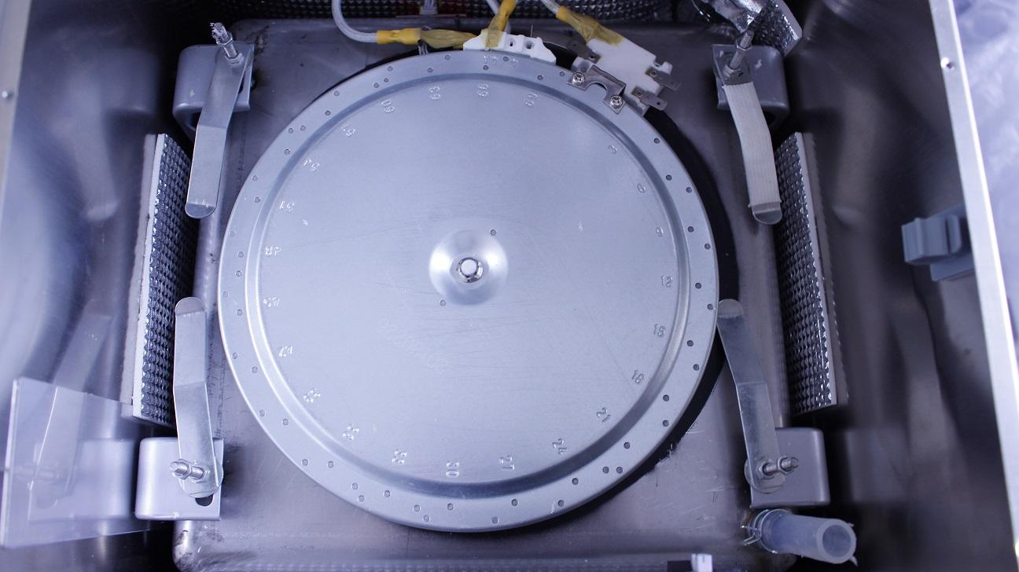

Reassemble consists of the same steps in reverse.

IMPORTANT! Don’t scratch the black heat paint under the element as any damage decreases the efficiency.